

Network Design & Management (IE 3010)

3rd Year, 1st Semester

Assignment

**Mail Server/Client Management**

Submitted to

Sri Lanka Institute of Information Technology

IT18091380

Vihanga Nivarthana

In partial fulfillment of the requirements for the

Bachelor of Science Special Honors Degree in Information Technology

2020/05/02

# DHCP Configuration

## Install and configure DHCP in Server machine

### **1.1.1** Install DHCP for configuration



#### Update OS

### **1.1.2** configuration by nmtui



#### Install DHCP

### **1.1.3** Select Edit a connection

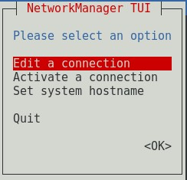

#### Install DHCP

### **1.1.4** Edit Wired connection 1 with Automatic IP configuration

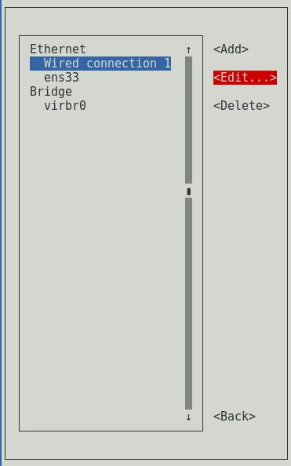

#### Edit Wired connection 1

#### Edit Connection and OK

### **1.1.5** Edit ens33 with Manual IPv4 configuration and go Back

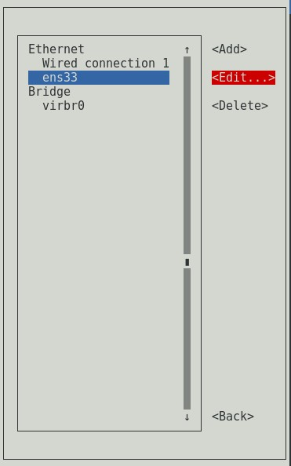

#### Edit ens33

#### Edit Connection and OK

### **1.1.6** Select Set system hostname and change the hostname as preferred

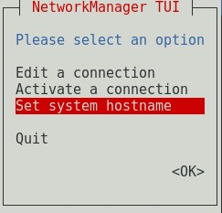

#### Set system hostname

#### Set Hostname and OK

### **1.1.7** Select Activate a connection and activate both network connections

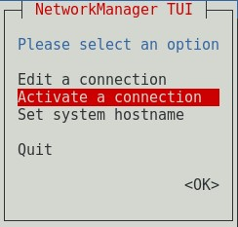

#### Activate a connection

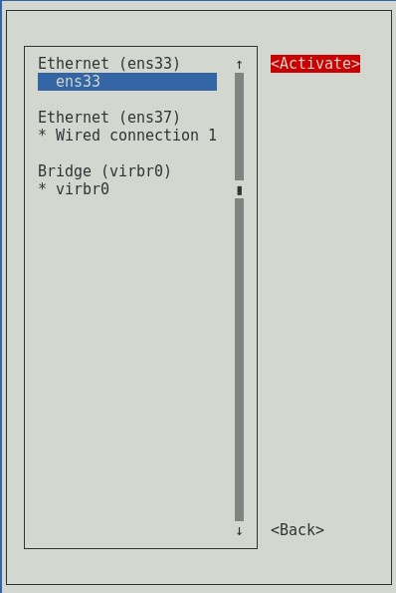

### **1.1.8** Click OK to exit from Network Manager TUI

#### OK to exit

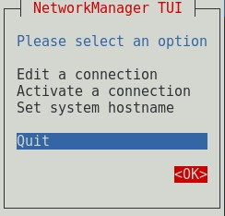

### **1.1.9** Check network configuration using ifconfig

#### Check network details

### **1.1.10** Open dhcpd file and add “DHCPDARGS=ens33” at the end of the file



#### Add network adapter details to DHCP file

### **1.1.11** Check dhcpd configuration file



#### Check DHCP configuration file

### **1.1.12** Copy the file to another destination. Click tab twice to show version number



#### Copy DHCP file to another location

### **1.1.13** Open dhcp configuration file and edit



#### Open DHCP configuration file to edit

### **1.1.14** Check DHCP service status and start service

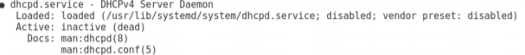

#### Check DHCP status

### **1.1.15** Start DHCP service and enable DHCP service to start at the OS startup



#### Start DHCP service





#### Enable DHCP to run at the startup

### **1.1.16** Check DHCP service status again



#### Check DHCP status

## Configure DHCP in Client machine

### **1.2.1** Following same procedure as previous open Network Manager with nmtui and Edit connection to Automatic DHCP

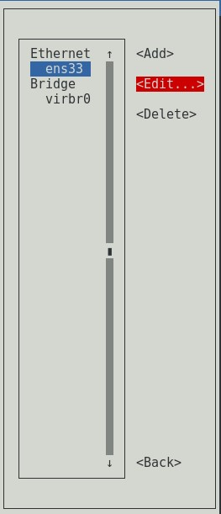

#### Edit ens33 connection

#### Edit Connection to Automatic DHCP

### **1.2.2** Change hostname as preferred and activate the connection

#### Set Hostname

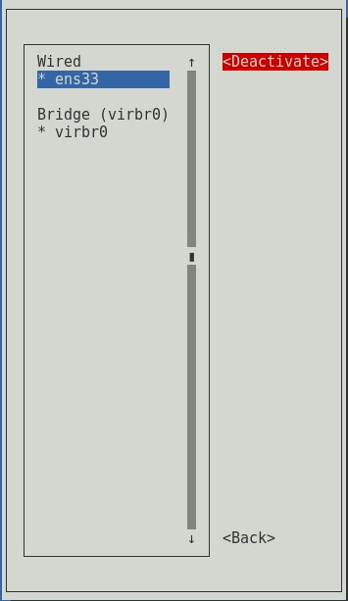

#### Activate the connection

### **1.2.3** Check received IP with ifconfig through DHCP server



#### Check network connection

# DNS Configuration

## Install and configure DNS in Server machine

### **2.1.1** Install bind for DNS configuration



#### figure 2.1 : Install bind

### **2.1.2** Stop DHCP service and restart network service



*figure 2.2 :* Stop DHCP service



*figure 2.3 :* Restart network service

### **2.1.3** Add hostname to the network system configuration file





*figure 2.4 :* Edit network file

### **2.1.4** Add host details to the hosts file

### 



*figure 2.5 :* Edit hosts file

### **2.1.5** Edit DNS configuration file and add zone details



*figure 2.6 :* Edit DNS configuration file

### **2.1.6** Create forward lookup zone file for DNS configuration



*figure 2.7 :* forward lookup zone file

### **2.1.7** Create reverse lookup zone file for DNS configuration



*figure 2.8 :* reverse lookup zone file

### **2.1.8** Stop DHCP and DNS services



*figure 2.9 :* Stop DHCP service



*figure 2.10 :* Stop DNS service

### **2.1.9** Edit DHCP configuration file for DNS configuration



*figure 2.11 :* Open DHCP configuration file to edit

### **2.1.10** Enable DNS service to start at startup and start DNS service

*figure 2.12 :* Enable DNS service



*figure 2.13 :* Start DNS service

### **2.1.11** Add port to allow through firewall and reload firewall





*figure 2.14 :* Add port



*figure 2.15 :* Reload firewall

### **2.1.15** Add DNS detail to the network adapter file

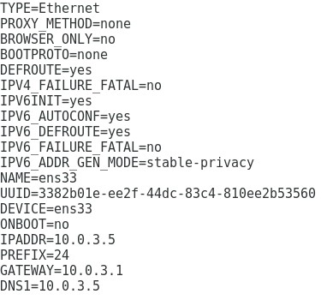

*figure 2.16:* Add DNS details

### **2.1.16** Restart the network service, DHCP service and DNS service



*figure 2.17 :* Restart network service



*figure 2.18 :* Restart DHCP service



*figure 2.19 :* Restart DNS service

### **2.1.17** Check DNS service status

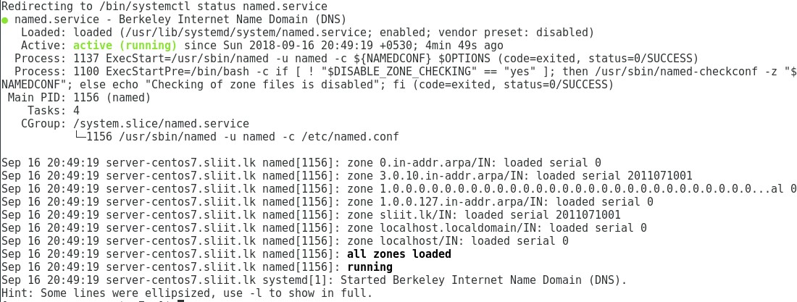

*figure 2.20 :* DNS service status

### **2.1.18** Check resolve configuration file to see configured DNS details

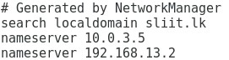



*figure 2.21 :* Check resolve configuration file

### **2.1.19** Check DNS details through dig and nslookup commands

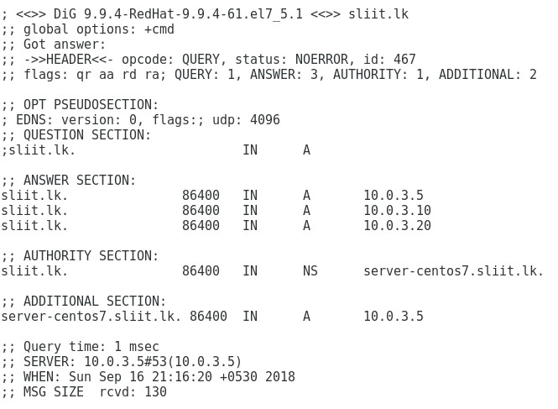



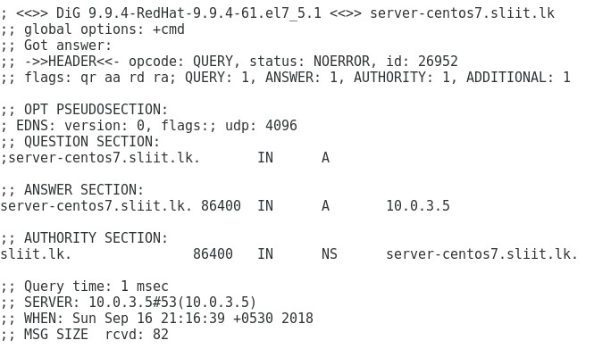

*figure 2.23 :* dig command with hostname

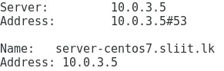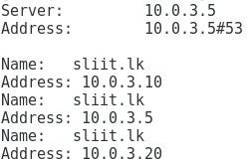

*figure 2.25 :* nslookup command with hostname

*figure 2.24 :* nslookup command with domain

## Configure DNS in Client machine

### **2.2.1** Add hostname to the network system configuration file



*figure 2.26 :* Edit network file

### **2.2.2** Add host details to the hosts file



*figure 2.27 :* Edit hosts file

### **2.2.3** Check resolve configuration file to see configured DNS details

### **2.2.4** Check DNS details through dig and nslookup commands

*figure 2.28 :* dig command with domain

*figure 2.29 :* 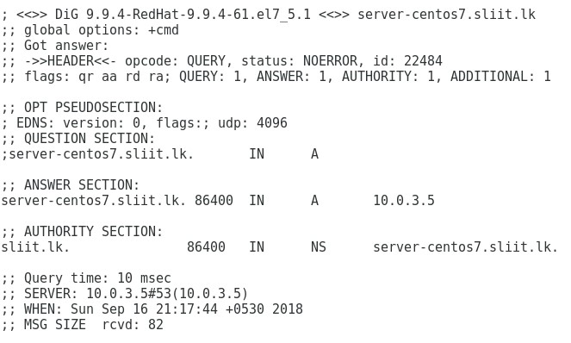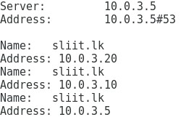dig command with hostname

*figure 2.30 :* nslookup command with domain

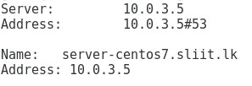

*figure 2.31 :* nslookup command with hostname

# Zimbra Installation

## Install Zimbra in CentOS 7 Server machine

### **3.1.1** Edit selinux system configuration file enforcing to disabled

*figure 3.1 :* Edit selinux file

### **3.1.2** Stop and disable the firewall service



*figure 3.2 :* Stop firewall service



*figure 3.3 :* Disable firewall service

### **3.1.3** Stop and disable the postfix service



*figure 3.3 :* Stop postfix service



*figure 3.4 :* Disable postfix service

### **3.1.4** Install required packages



*figure 3.5 :* Install required packages

### **3.1.5** Edit forward lookup zone file for mail forwarding access

*figure 3.6 :* Edit forward lookup zone file

### **3.1.5** Make a new directory and switch to it



*figure 3.7 :* Make directory



*figure 3.8 :* Change directory

### **3.1.6** Download Zimbra installation file to the desktop and unzip it in new directory



*figure 3.9 :* Unzip Zimbra file

### **3.1.7** Switch to the unzip folder and run the installation file

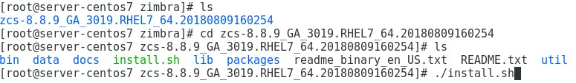

*figure 3.10 :* Switch to folder and run installer

### **3.1.8** Accept terms of the software license agreement and to use Zimbra’s package repository



*figure 3.11 :* License agreement



*figure 3.12 :* Repository packages

### **3.1.9** Select required packages to install

*figure 3.12 :* Packages to install

### **3.1.10** Change hostname and domain name if required



 *figure 3.13 :* Change hostname

*figure 3.14 :* Change domain name

### **3.1.11** Configure unset values and continue process

*figure 3.15 :* 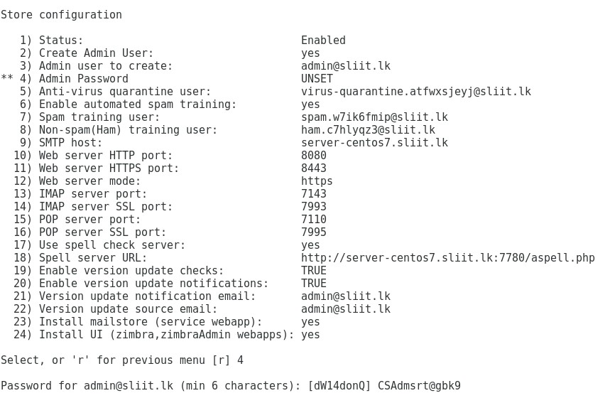Main menu

### 

*figure 3.16 :* Store configuration

### **3.1.12** Login to Zimbra and check Zimbra control status



*figure 3.16 :* 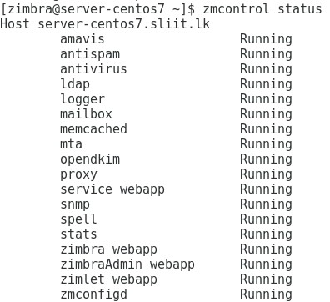Login to Zimbra

*figure 3.17 :* Zimbra control status

### **3.1.13** Switch to Zimbra mail configured IP address using web browser and login

:

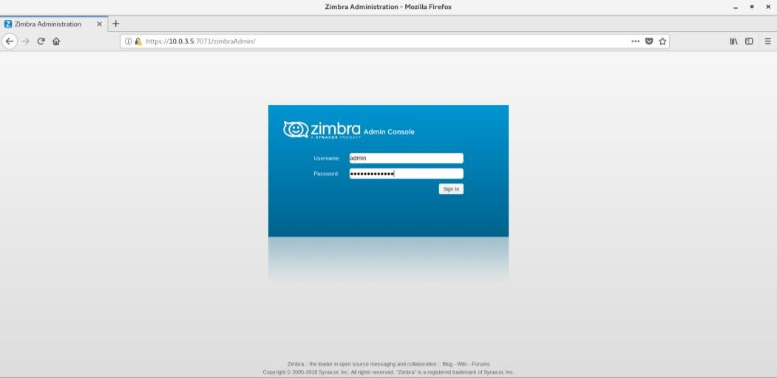

*figure 3.17 :* Zimbra admin console

### **3.1.14** Click Add Account to add user account

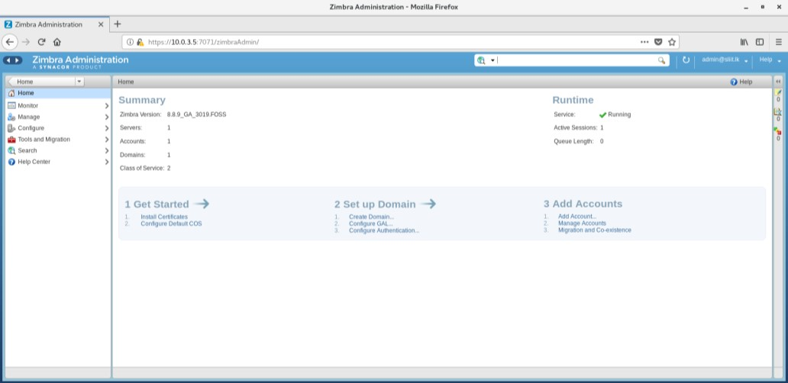

*figure 3.18 :* Zimbra home page

### **3.1.16** Add required details and create new user account

:

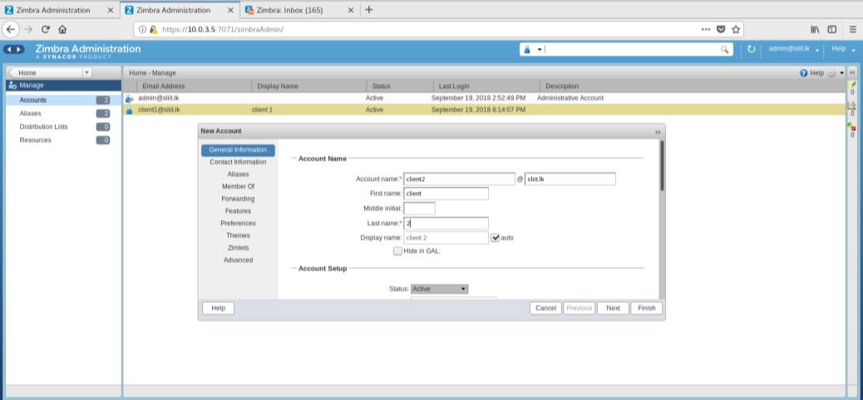

*figure 3.19:* Add account

### **3.1.15** Login to administrator mail account

.

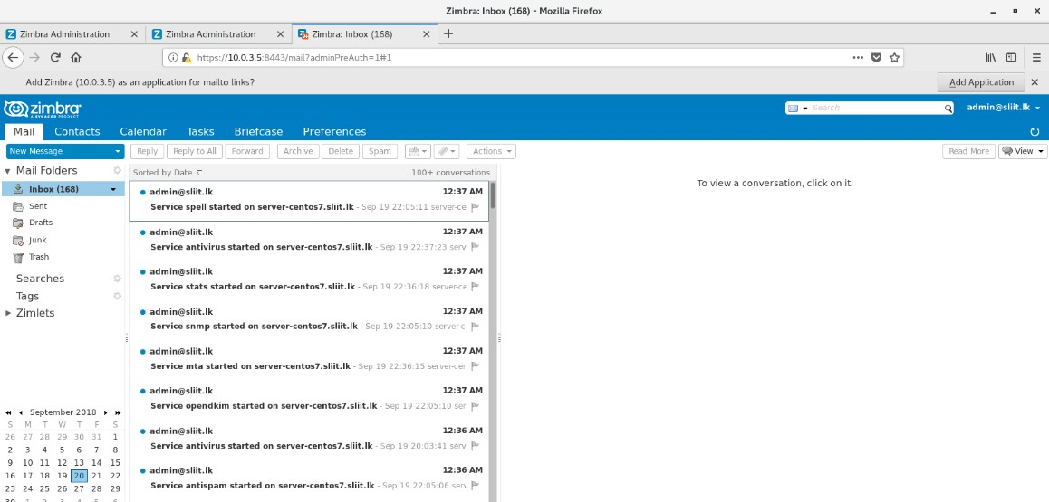

*figure 3.20 :* Zimbra admin mail account

### **3.1.16** Login to client mail account

.

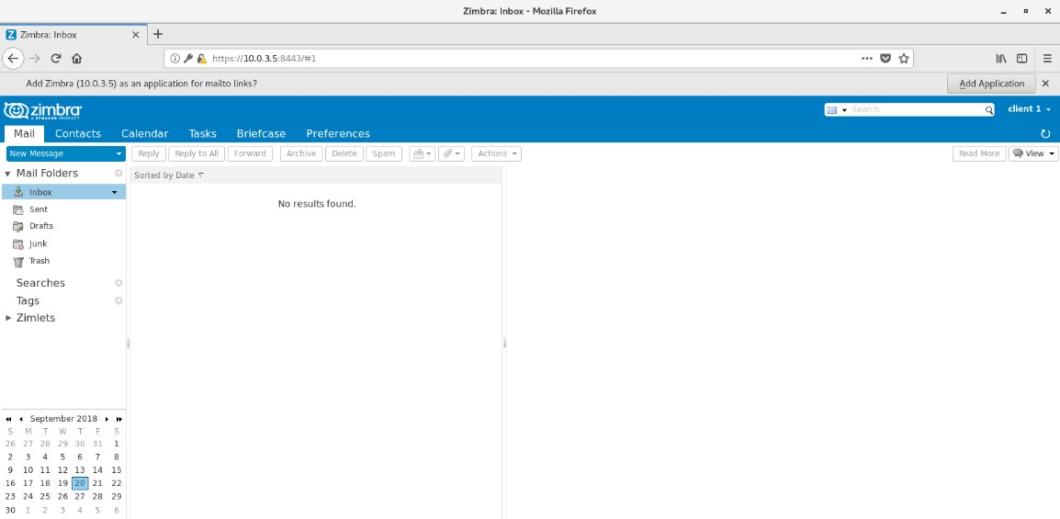

*figure 3.20 :* Zimbra client mail account

**Declaration**

I certify that this report does not incorporate without acknowledgement, any material previously submitted for a degree or diploma in any university, and to the best of my knowledge and belief it does not contain any material previously published or written by another person, except where due reference is made in text.

By,

Vihanga Nivarthana